A Church on the way: Take the Way of the Gospel 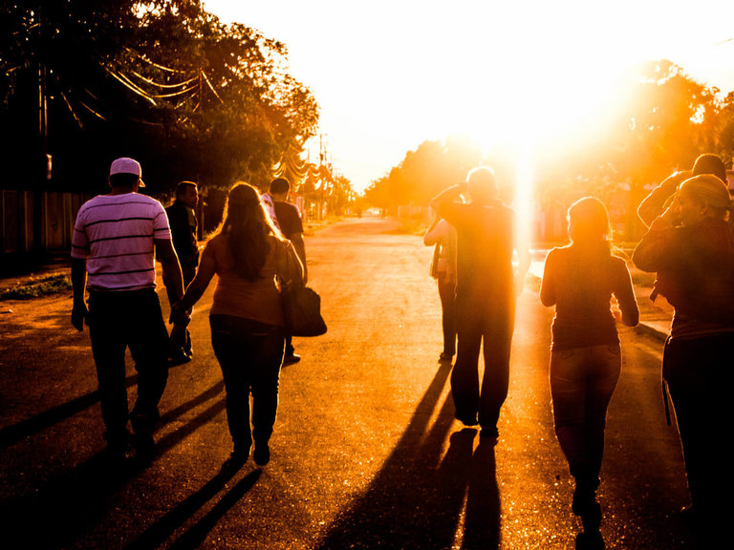
PUBLISHED27 September 2021 WRITTEN BY Melbourne Catholic

In August, Pope Francis dedicated his monthly prayer intention to the specific vocation of the Church: to evangelise. Reiterating the words from his Apostolic Exhortation Evangelii Gaudium (The Joy of the Gospel), he said he dreams of an even more 'missionary option' for the Church: 'one that goes out to meet others without proselytism and transforms its structures for the evangelisation of today’s world.'
The Pope invited everyone to pray for the Church, 'that she may receive from the Holy Spirit the grace and strength to reform herself in the light of the Gospel.'
'A reform,' he said, 'does not consist in words, but in attitudes that have the courage to face the crisis.' Pope Francis is also realistic about the pains that reform can bring: 'Let us remember that the Church always has difficulties,' he said, explaining that the Church goes through crises 'because she is alive', and that only the dead don't experience crises!

A call to renewal
Missionary renewal has long been a focus of Francis' papacy. Within the first few paragraphs of Evangelii Gaudium (2013), the Pope invited Christians everywhere, 'at this very moment, to a renewed personal encounter with Jesus Christ, or at least an openness to letting him encounter them; I ask all of you to do this unfailingly each day.' (§3)
'I want to emphasize that what I am trying to express ... has a programmatic significance and important consequences,' Pope Francis continued. 'I hope that all communities will devote the necessary effort to advancing along the path of a pastoral and missionary conversion which cannot leave things as they presently are. “Mere administration” can no longer be enough. Throughout the world, let us be “permanently in a state of mission”. (§25) He goes on:

'The renewal of structures demanded by pastoral conversion can only be understood in this light: as part of an effort to make them more mission-oriented, to make ordinary pastoral activity on every level more inclusive and open, to inspire in pastoral workers a constant desire to go forth and in this way to elicit a positive response from all those whom Jesus summons to friendship with himself.' (§27)
The way of the Gospel—the path of missionary discipleship—has always been adapted by every generation to fit the local circumstances. How this is arranged has varied according to time and place, and the prayerful discernment of the local people of faith. Pope Francis has said that for pastoral ministry to truly be mission-oriented, it must abandon the complacent attitude that says: “We have always done it this way”, and for everyone 'to be bold and creative in this task of rethinking the goals, structures, style and methods of evangelization in their respective communities.' (§33)
Another theme of his papacy has been his call for a more "synodal church", that is, a church ‘which listens, which realises that listening is more than simply hearing’. 'It is a mutual listening in which everyone has something to learn. The faithful people, the college of bishops, the Bishop of Rome: all listening to each other, and all listening to the Holy Spirit, the Spirit of Truth' (EG, §171).
Indeed the 2023 Synod on Synodality, which will be launched on the final day of Australia's own Plenary Council, might be seen as the culmination of Pope Francis' desire for the Church to constantly be renewed in light of the Gospel, and whose disposition is one of communal discernment and deep listening to the Holy Spirit. Being a synodal Church means the People of God journeying together, with each of the baptised called upon to take an active part in the Church's evangelising mission.

A renewal closer to home: Take the Way of the Gospel
At Pentecost this year, Archbishop Peter A Comensoli invited the people of faith in Melbourne into a conversation about ‘our common mission for the years ahead'.
To begin the conversation, the Archbishop initially met with clergy and lay representatives from the Archdiocese’s 210 parishes. ‘These initial meetings had one purpose in mind,’ he said. ‘To open up the question as to how our local Church in Melbourne might best be organised into the future, such that the mission of the Gospel is at the heart of our life, worship and outreach; local faith communities are arranged to allow for them to flourish and that our faith communities be effectively resourced – spiritually, ministerially and materially.’
'For decades, the clergy and faithful of Melbourne have been exploring ways to bring about a re-framing of the local Church to become more vital for God’s people.' the Archbishop said.
'The challenges, wounds and disruptions of recent years, coupled with the life-changing reality of the COVID pandemic, have opened my own eyes, ears and heart to recognise that our present way of doing things needs to be re-imagined in the face of the changing circumstances in which we live.'
Archbishop Comensoli is proposing a 're-framing of how our local communities of grace, be they parishes, language communities, or movements are arranged.' The framework being offered is that of "Missions": distinctive faith localities that lend themselves to being lived in family-like arrangements.

Together they would take a collaborative focus on evangelisation, worship, formation and outreach, thus working together as a "family of communities" towards vibrancy, vitality and viability.
'While the language of "mission" is familiar to us, imagining how it is to be realised in our parochial contexts of today is always a "beginning", and many questions will arise,' said the Archbishop.
'St John Paul II, in Redemptoris Missio, explained that "mission" is the way to revitalise faith and our Christian life. He said that the Lord is 'always calling us to come out of ourselves' and 'to share with others the goods we possess, starting with the most precious gift of all – our faith.' For any of the Church's organisations, movements, parishes, and apostolic works to be effective, 'it must be measured in the light of this missionary imperative' (§49).
The Archbishop believes large numbers of individual parishes will always exist in the Archdiocese, but acknowledges that other parochial structures beyond a single parish community also exist and have been flourishing. 'Some involve a few neighbouring parishes; others of several communities coalescing around one common location; some have grown from a single community into multiple communities, and some stretch over several locations or are not territorially-based. But all of them find their local purpose in advancing the universal missionary call given in Christ to every faith community,'
'Hence, the driving idea of a Mission is that of the formation of a "family" of local faith communities – a common surname if you will, with individual first names – that seeks to give impetus to this missionary impulse.'
'Other names have been adopted elsewhere – cluster, group, twinned, hub, unit, region, etc. Whatever the name, Mission is what gives these arrangements their purpose and drive,' he said. 'A Mission is not a structure, but a name and a way.'
'Our parishes will remain at the heart of the gathering of God’s people locally, but we need to adapt the way we resource our local communities, including the placement of clergy, catechists and other lay leaders, to form Missions that comprise a family of faith communities,' Archbishop Comensoli added.
This re-framing and revitalisation for the sake of missionary renewal will necessarily take time. While parish priests and lay leaders are being encouraged to begin their local discussions, the Archbishop believes it may take up to three to five years before the Missions truly come to life, and even then, it will be a process of continual discernment. 'Some Missions will be very readily identifiable and need to be established quickly, while others will take time to develop,' he said. 'This will be a journey that will take time and effort, and we will need to take it together.'
As Pope Francis stresses in Evangelii Gaudium: 'Each Christian and every community must discern the path that the Lord points out ... to go forth from our own comfort zone in order to reach all the “peripheries” in need of the light of the Gospel.’ (§20)

A task for all the People of God
Following the Archbishop's initial meetings with clergy and lay leaders, more than 20 regional meetings have been hosted with almost 1,000 faithfull in attendance.
These gatherings (held online due to Victoria's extended lockdown) explored what Missions are (an intentional co-responsibility of the People of God) and what they are not (a way of closing down parishes). Research firm Location IQ presented some key data around Mass attendance, demographics, geography, thanksgiving income, pastoral load and future population growth. Based on this initial data, illustrative Missions were proposed in each region as an initial logic or starting point for parishes to begin exploring what will be possible.
Parish priests and lay leaders have now been invited to spend the next few months reflecting on the proposals presented and, drawing on their own local experiences and expertise, open up the conversation to the wider community. Ongoing support will be offered by staff from Proclaim: The Office for Mission Renewal and a mechanism for ongoing feedback has been created to ensure key questions and learnings can be shared with parishes along the way.
Archbishop Comensoli has also indicated that not every Mission will look the same, and that it will be up to local parishes to discern carefully and faithfully what will be feasible.
Fr Anthony (Tony) Kerin, Episcopal Vicar for the Eastern Region and Parish Priest of Box Hill shared that he is excited and optimistic about the Archbishop’s invitation to ‘re-think mission’ within the Archdiocese.
‘Take the Way of the Gospel is the Archbishop’s strategy for evangelising and opening the Church to people who are no longer coming to see us or who have never heard about the message of Jesus,’ Fr Tony said.
‘We are called to be missionary. Jesus said, “Go and make disciples of all nations.” He didn’t say, “Go and be disciples, alone.” It’s not sufficient just to be disciples, we have to make new disciples. That’s the great commission, our call, at the end of Matthew’s Gospel. It’s compulsory.’
‘What’s optional, however, is how the church takes on its missionary character, taking into account the local situation and circumstances.'
The Pope's invitation to be bold in rethinking goals, structures and methods of evangelisation is beginning to take shape in the Take the Way of the Gospel project, but as Fr Tony reflects, it is now up to parishes to think creatively about how this might happen.
‘The ideas have been outlined by the Archdiocesan team, but now the discernment in the local area is what’s going to take the task, that’s what’s going to require them to connect,' he said.
‘Parishes will still continue ... they’ll still be there and they’ll still have their parish priest and parish council, and all of that sort of thing, but working in mission gives them an opportunity to be bigger than themselves and to do things they couldn’t afford to do on their own, and to share in the resources and the volunteers that a greater group of people provide.’

Retrieved from https://melbournecatholic.org/news/a-church-on-the-way accessed 29/09/2021.
Further information available at https://melbournecatholic.org

